


G H Patel College of Engineering & Technology
(The CVM University)
New V. V. Nagar

COMPUTER ENGINEERING DEPARTMENT

Branch :- Computer Science And Design

Mini Project Report on
Smart Online Classroom & Meeting Platform with Behavioral Analytics

Submitted By

Name of Student : Namra Gajera
Enrolment Number : 12302130501038
Name of Student : Hit Gardhariya
Enrolment Number : 12302130501024

Guided By
Dr.Namrata Pandya

MINI PROJECT (202040601)
A.Y. 2025-26 EVEN TERM




CERTIFICATE

This is to certify that the Mini Project Report submitted entitled “Smart Online Classroom & Meeting Platform with Behavioral Analytics” has been carried out by Namra Gajera (12302130501038) under guidance in partial fulfillment for the Degree of Bachelor of Engineering
& Technology in Computer Science and Design, 6th Semester of G H Patel College of Engineering & Technology, CVM University, New Vallabh Vidyanagar during the academic year 2025-26.

Dr.Namrata Pandya Prof. Sudhir Vegad

Internal Guide Head of Department




CERTIFICATE

This is to certify that the Mini Project Report submitted entitled “Smart Online Classroom & Meeting Platform with Behavioral Analytics” has been carried out by Hit Gardhariya (12302130501024) under guidance in partial fulfillment for the Degree Bachelor of Engineering
& Technology in Computer Science and Design, 6th Semester of G H Patel College of Engineering & Technology, CVM University, New Vallabh Vidyanagar during the academic year 2025-26.

Dr.Namrata Pandya Prof. Sudhir Vegad

Internal Guide Head of Department

ACKNOWLEDGEMENT
We express our sincere gratitude to our guide Dr. Namrata Pandya for her invaluable guidance, continuous support, and encouragement throughout the development of this project. Their expertise in the field of software engineering, full-stack web development, and machine learning helped us navigate the complexities of building an integrated real-time classroom platform with embedded behavioral intelligence.
We are also grateful to Prof. Sudhir Vegad, Head of the Department of Computer Engineering, G H Patel College of Engineering & Technology, CVM University, for providing us with the necessary resources and a supportive learning environment that made this project possible.
We would also like to acknowledge the efforts and dedication of our group member Hit Gardhariya for their equal contribution, collaborative spirit, and commitment to delivering a technically sound and educationally relevant system throughout the academic year 2025-26.

ABSTRACT
The Smart Online Classroom and Meeting Platform with Behavioral Analytics is a comprehensive full-stack web application designed to address the growing demands of modern digital education. As the adoption of remote and hybrid learning continues to accelerate globally, existing platforms such as Zoom, Google Meet, and Microsoft Teams offer general-purpose video conferencing capabilities but lack the academic context-awareness, granular control features, and intelligent behavioral monitoring that educational institutions specifically require. The present system is built to fill this gap by integrating real-time video communication, classroom management, collaborative tools, and machine learning-powered behavioral analytics into a single cohesive platform.
The system operates on a role-based architecture distinguishing between two primary user types: Teachers, who serve as meeting hosts and session administrators, and Students, who participate as meeting attendees subject to host-controlled access. The platform implements a WebRTC-based peer-to-peer video and audio communication layer managed through a Socket.IO signalling server, enabling low-latency, browser-native real-time meetings without requiring proprietary plugins or external clients.
A distinctive feature of the system is its Waiting Room module, which requires each student to request entry into an active session. The teacher retains full approval authority, reviewing and individually admitting or rejecting each student before they gain access to the live meeting environment. This mechanism provides the kind of access control essential for formal educational settings where unauthorized entry disrupts the learning environment.
The platform's collaborative layer includes an in-session chat system with support for file sharing, a screen sharing module with host-permission gating, and a Poll and Quiz system that allows teachers to deploy real-time assessments during live sessions and review aggregated student responses instantly. Meeting scheduling is supported through an integrated calendar interface that notifies participants of upcoming sessions.
Attendance tracking is automated and session-aware: the system records each participant's join and leave timestamps, computes session duration, and exposes export functionality allowing teachers to download attendance records in both PDF and CSV formats for institutional record-keeping.
The most technically distinctive component of the system is its Behavioral Analytics Engine. This module continuously collects four key interaction metrics during a live session: idle time, tab switching frequency, session duration, and break count. These features are transmitted to a standalone Python Flask microservice that runs a trained RandomForestClassifier model built using Scikit-learn. The model produces three outputs: an attention status classification (Attentive, Moderately Attentive, or Distracted), a normalized engagement score on a scale of 0 to 100, and a cognitive load estimate. These outputs are returned to the Node.js backend, persisted in MongoDB, and surfaced to teachers through a per-student analytics dashboard.
The entire platform is deployed as a containerized system using Docker and Docker Compose, bundling the Node.js application server, MongoDB instance, and Python Flask ML microservice into a unified deployment configuration. The system is architecturally designed for horizontal scalability, fault tolerance, and extensibility, with clean API boundaries between the frontend, backend, and ML layers.

TABLE OF CONTENTS
Sr. No. | Chapter / Section | Page No.
 | Acknowledgement | 1
 | Abstract | 2
 | Table of Contents | 4
1 | Introduction | 6
1.1 | Problem Statement | 6
1.2 | Project Overview | 7
1.3 | Aim & Objective of the Project | 8
2 | System Analysis | 10
2.1 | Motivation | 10
2.2 | Literature Study | 11
3 | Design: Analysis & Methodology | 13
3.1 | Requirement Analysis | 13
3.2 | System Architecture | 14
3.3 | Module Specification | 15
3.4 | Timeline Chart | 18
3.5 | UML Diagrams | 19
4 | Implementation | 22
4.1 | System Flow | 22
4.2 | Data Flow Diagrams | 25
4.3 | API Implementation Overview | 26
4.4 | Database Implementation | 27
4.5 | Frontend Application | 28
4.6 | ML Microservice | 29
4.7 | Results & System Testing | 30
5 | Conclusion and Future Work | 39
 | References | 42

LIST OF FIGURES
Figure No. | Figure Title | Page No.
Figure 1 | Entity-Relationship (ER) Diagram | 19
Figure 2 | Class Diagram (Models and their usage by Service Functions) | 20
Figure 3 | Use Case Diagram (Teacher and Student Actors) | 21
Figure 4 | Data Flow Diagram (Level 0 - Context Diagram) | 26
Figure 5 | Data Flow Diagram (Level 1) | 26
Figure 6 | Project Results | 32

LIST OF TABLES
Table No. | Table Title | Page No.
Table 3 | Timeline Chart | 18
Table 4 | API Endpoints Summary | 27
Table 5 | Database Models Summary | 28
Table 6 | System Test Cases | 31

CHAPTER 1: INTRODUCTION
1.1 PROBLEM STATEMENT
The rapid global adoption of remote and hybrid learning models has exposed critical limitations in existing digital communication and classroom management tools. While platforms such as Zoom, Google Meet, and Microsoft Teams offer robust general-purpose video conferencing, they are not purpose-built for formal academic environments and lack several features essential to effective digital pedagogy. The following specific challenges define the problem context for this project:
- Absence of host-controlled entry management: Existing platforms offer waiting rooms as an optional feature, but do not provide granular, session-integrated approval workflows that allow teachers to review and individually admit students.
- Lack of academic collaboration tools within the meeting interface: Features such as in-session polls, quizzes, and structured file sharing are typically absent or available only as paid add-ons in general-purpose platforms.
- No integrated attendance tracking: Teachers using general video conferencing platforms must manually record attendance through external spreadsheets or third-party plugins, creating fragmentation in the academic workflow.
- No behavioral intelligence: Existing platforms collect no data on student engagement, attention level, or cognitive load during sessions, making it impossible for teachers to identify disengaged students or adapt session delivery in real time.
- Data privacy and institutional control: Cloud-hosted platforms offer limited control over student data, raising compliance concerns for educational institutions operating under data protection regulations.
- Fragmented tooling across multiple services: Teachers are forced to coordinate meetings on one platform, share files on another, manage assessments on a third, and track attendance manually, resulting in severe workflow fragmentation and reduced teaching efficiency.
1.2 PROJECT OVERVIEW
The Smart Online Classroom and Meeting Platform is a three-tier full-stack web application providing end-to-end digital classroom coverage for educational institutions. The system integrates real-time video communication, classroom access management, collaborative tools, automated attendance, and machine learning-powered behavioral analytics into a unified, self-hosted platform.
The platform consists of three primary software components developed in a coordinated, API-driven architecture:
- Backend API Server (Node.js + Express): Handles all core business logic including authentication, role-based access control, meeting management, waiting room approval, chat and file processing, poll/quiz management, attendance tracking, scheduling, and coordination with the ML microservice.
- Frontend Application (HTML, CSS, JavaScript): A responsive, browser-native web interface providing separate role-adapted dashboards for teachers and students, real-time meeting UI with WebRTC video streams, interactive analytics views, calendar scheduling, and attendance export tools.
- ML Behavioral Analytics Microservice (Python Flask + Scikit-learn): A standalone REST API that receives behavioral feature vectors collected during sessions, runs inference through a trained RandomForestClassifier, and returns attention status, engagement score, and cognitive load estimates to the main backend.
Together, these components form a cohesive, institutionally deployable classroom ecosystem that operates entirely within the browser, requires no proprietary client software, and is containerized for straightforward deployment using Docker Compose.
1.3 AIM & OBJECTIVE OF THE PROJECT
The primary aim of this project is to design and deploy a comprehensive, self-contained digital classroom platform that enables effective remote teaching, provides teachers with actionable intelligence about student engagement, and delivers an institutionally appropriate, privacy-preserving alternative to general-purpose conferencing tools.
Specific Objectives:
- Design and implement a secure, scalable RESTful backend capable of handling multi-role authentication, real-time meeting lifecycle management, and all associated classroom operations.
- Build a responsive, browser-native frontend providing role-specific dashboards for teachers and students, with intuitive meeting, scheduling, and analytics interfaces.
- Implement a WebRTC-based peer-to-peer video and audio communication layer managed through a Socket.IO signalling server, enabling browser-native real-time meetings.
- Develop a Waiting Room system that gives teachers full control over student entry into live sessions, preventing unauthorized access and maintaining session integrity.
- Implement in-session collaboration tools including real-time chat with file sharing, host-approved screen sharing, and live poll and quiz capabilities.
- Build an automated, session-aware attendance tracking system with PDF and CSV export functionality for institutional record-keeping.
- Develop a meeting scheduling and calendar management module enabling teachers to plan and announce sessions in advance.
- Train and deploy a RandomForestClassifier-based ML model as a Flask microservice that analyzes behavioral metrics and produces attention status, engagement score, and cognitive load outputs.
- Ensure the system operates reliably as a containerized deployment using Docker and Docker Compose, providing a straightforward path to institutional self-hosting.

CHAPTER 2: SYSTEM ANALYSIS
2.1 MOTIVATION
The COVID-19 pandemic fundamentally transformed the global educational landscape, accelerating the adoption of digital learning platforms by several years within a matter of weeks. While this transition demonstrated that remote education is technically feasible at scale, it also revealed the profound inadequacy of existing tools when applied to the specific demands of formal academic instruction. General-purpose video conferencing platforms were repurposed for classroom delivery without the design considerations that educational contexts require.
The motivation for this project stems from four core observations derived from the analysis of existing remote learning deployments:
- Reactive classroom management: Teachers using existing platforms have no systematic mechanism to understand whether students are paying attention, have switched to unrelated browser content, or have become cognitively overloaded during a complex session. Teaching decisions are made without behavioral feedback, reducing pedagogical effectiveness.
- Tool fragmentation increases cognitive load on educators: Teachers operating across a video platform for meetings, a spreadsheet for attendance, a separate quiz tool for assessments, and an email client for scheduling face significant overhead. A unified platform reduces this overhead substantially.
- Institutional data control: Educational institutions operating under data protection regulations face significant compliance risks when student interaction data is processed and stored exclusively on third-party commercial cloud infrastructure. A self-hosted, containerized platform restores institutional control over sensitive student data.
- Behavioral analytics as a proactive teaching tool: The emerging discipline of learning analytics demonstrates that behavioral signals such as attention patterns, session engagement levels, and interaction frequency are measurable and actionable. Providing this intelligence to teachers in real time enables proactive, data-driven adaptation of teaching delivery.
2.2 LITERATURE STUDY
The following key works informed the design and technical decisions of this project:
- Sredojev et al. (2015) provide a comprehensive technical overview of the WebRTC protocol stack, signalling architectures, and peer connection establishment mechanisms. Their analysis of ICE candidate exchange procedures directly informed the Socket.IO-based signalling design implemented in the meeting module of this system.
- Alvestrand (2013), in the IETF RFC Draft on Real Time Protocols for Browser-based Applications, establishes the foundational standards governing WebRTC's security model, including DTLS-SRTP media encryption and STUN/TURN-based NAT traversal. These standards form the security baseline of the video communication layer.
- Whitehill et al. (2014), in their IEEE Transactions on Affective Computing study, demonstrate that student engagement can be automatically recognized from behavioral signals with high accuracy. Their multi-class attention classification framework (attentive, distracted, and intermediate states) directly inspired the three-class output design of the RandomForestClassifier deployed in this project.
- Bosch et al. (2021) examine the relative performance of human versus automated engagement detection in educational contexts, establishing that machine learning models trained on interaction features can achieve detection accuracy comparable to trained human observers. This finding validates the interaction-based (rather than camera-based) behavioral analytics approach chosen for this project.
- Mayer and Moreno (2003) introduce the Cognitive Load Theory of multimedia learning, identifying that cognitive overload is a primary obstacle to effective digital instruction. Their framework provided the theoretical basis for including cognitive load as a distinct output metric of the behavioral analytics engine, alongside attention status and engagement score.
- Farooq et al. (2021) conduct a security analysis of virtual meeting platforms, identifying unauthorized entry, session hijacking, and participant impersonation as primary threat vectors in academic video conferencing environments. Their recommendations for mandatory host-controlled approval mechanisms directly motivated the design of the Waiting Room module.
- Breiman (2001) introduces the Random Forests ensemble learning method, providing the theoretical foundation for the classifier selected for the behavioral analytics engine. Random Forests' robustness to noisy features and resistance to overfitting on small training datasets made it the appropriate algorithm choice for the limited behavioral feature set available per session.
- Pedregosa et al. (2011) describe the Scikit-learn machine learning library, which was used for model training, serialization, and inference. Its predict_proba() API, which returns class probability distributions rather than hard class labels, enabled the engagement score computation formula implemented in the Flask microservice.

CHAPTER 3: DESIGN - ANALYSIS & METHODOLOGY
3.1 REQUIREMENT ANALYSIS
3.1.1 System Requirements
Hardware Requirements:
- Processor: Intel Core i3 or equivalent (minimum); i5 or higher recommended for running Docker containers simultaneously.
- RAM: 8 GB minimum; 16 GB recommended for running Node.js server, MongoDB, and Flask microservice concurrently in Docker.
- Storage: 10 GB minimum available disk space for application files, MongoDB data directory, Docker images, and uploaded meeting files.
- Network: Stable broadband internet connection (minimum 5 Mbps upload/download per participant) required for WebRTC peer-to-peer video communication.
Software Requirements:
- Operating System: Ubuntu 20.04 LTS or later (server deployment); Windows 10/11 or macOS 12+ (development environment).
- Runtime: Node.js v18 LTS or later with npm v9 or later.
- Database: MongoDB v6.0 or later.
- ML Environment: Python 3.9 or later with Flask 3.x, Scikit-learn 1.3.x, NumPy 1.24.x, and Gunicorn 21.x.
- Containerization: Docker Engine v24 or later with Docker Compose v2.x.
- Browser: Google Chrome 115+ or Mozilla Firefox 115+ (WebRTC support required).
3.2 SYSTEM ARCHITECTURE
The system is structured as a three-tier, four-layer architecture organized around a central Node.js backend with isolated frontend and ML components:
- Presentation Layer: Two distinct browser-based interfaces serve the two user roles. The Teacher Interface provides a multi-panel dashboard encompassing meeting management, live session hosting, student approval controls, attendance reporting, and the analytics dashboard for engagement monitoring. The Student Interface provides the meeting calendar, waiting room view, live session participation interface, and personal session report. Both interfaces communicate with the backend via RESTful HTTP APIs and maintain persistent Socket.IO connections for all real-time events.
- Application Layer: The Node.js Express backend contains six domain-specific service modules. The Auth Service handles JWT-based authentication and role-based access control. The Meeting Service manages room lifecycle including creation, scheduling, participant tracking, and status management. The Waiting Room Service maintains the approval queue and coordinates Socket.IO events between students and teachers. The Collaboration Service processes chat messages, file uploads, screen share permission grants, and poll/quiz operations. The Attendance Service tracks per-session join/leave events and handles PDF and CSV export generation. The Analytics Coordinator receives behavioral event streams from the frontend, batches them, and forwards feature vectors to the ML Flask microservice.
- ML Microservice Layer: The Python Flask service operates as an isolated prediction API. It exposes a single POST endpoint that receives a behavioral feature vector and returns model predictions. The RandomForestClassifier is loaded into memory at server startup and runs synchronous inference for each request, returning the attention status, engagement score, and cognitive load estimate to the Node.js backend.
- Data Layer: MongoDB serves as the primary data store maintaining eight collections: Users, Meetings, WaitingRoom, ChatMessages, Attendance, Polls, AnalyticsEvents, and EngagementReports. No data is stored in the ML microservice; all prediction outputs are persisted by the Node.js backend to MongoDB.
- Real-Time Gateway Layer: Socket.IO manages all event-driven communication including WebRTC signalling (offer, answer, ICE candidate exchange), waiting room notifications, chat message broadcasting, attendance event triggering, and live poll response updates.
3.3 MODULE SPECIFICATION
Module 1: Authentication & Role Management
Handles registration and login for both teachers and students. Passwords are hashed using bcrypt before storage in MongoDB. Upon successful authentication, a signed JWT is issued containing the user's ID, role, and name. A middleware function validates the JWT on all protected routes and extracts the role to enforce access control. Teachers can access administrative endpoints, meeting creation routes, and the analytics dashboard. Students are restricted to meeting participation and personal report endpoints. As part of the registration workflow, students are required to select one or more teachers from a presented list; this multi-teacher mapping is stored in the Users collection and subsequently used to filter each student's upcoming meetings view so that only sessions hosted by their associated teachers are surfaced on the student dashboard.
Module 2: Real-Time Video Meeting (WebRTC + Socket.IO)
The meeting module manages the complete lifecycle of a live classroom session. When a teacher creates a meeting, a unique alphanumeric room ID is generated and stored in MongoDB. WebRTC peer connections are established using a signalling exchange over Socket.IO. When a student joins, their browser generates an SDP offer which is relayed via Socket.IO to the teacher's browser. The teacher's browser generates an SDP answer, and ICE candidates are exchanged bidirectionally until a peer connection is established. The system supports multi-party meetings using a selective forwarding model where each participant maintains peer connections with all other participants in the room.
Module 3: Waiting Room System
The Waiting Room module implements a host-controlled entry queue. When a student navigates to a meeting link, they are held in a waiting room state and a join request event is emitted via Socket.IO to the teacher's active dashboard. The teacher's interface displays a real-time queue of pending students with their names and request timestamps. The teacher can individually approve or reject each student. On approval, a Socket.IO admission event is emitted to the specific student's connection, transitioning their interface from the waiting room view to the live meeting view. On rejection, the student receives a denial notification.
Module 4: Collaboration Tools (Chat, File Sharing, Screen Share, Polls)
The collaboration module encompasses four sub-components. The Chat System uses Socket.IO to broadcast text messages to all participants in a room in real time. File sharing is implemented via a multipart form upload to the Node.js backend, where files are stored on the server filesystem and a download URL is broadcast to all meeting participants via Socket.IO. Screen sharing uses the browser's getDisplayMedia API; students must request permission from the host, and the teacher is presented with a dedicated Approve or Reject modal for each incoming request. Concurrent screen share requests are managed through a sequential queue, ensuring that multiple simultaneous requests from different students are handled in order without any request being silently discarded. The Poll and Quiz System allows teachers to publish multiple-choice questions to all participants during a live session. Student responses are collected and aggregated in real time, with results displayed on the teacher's dashboard.
Module 5: Attendance Tracking & Export
Attendance is tracked automatically at the session level. When a participant joins a meeting (after waiting room approval), an attendance record is created in MongoDB with their userId, meetingId, and joinTime. When they disconnect, the leaveTime and computed duration are updated on the same record. At any time after a session, the teacher can request an attendance export for a specific meeting via a GET request. The server generates a PDF using PDFKit or a CSV using json2csv, populated with all attendance records for the meeting, and returns the file for immediate download.
Module 6: Meeting Scheduling & Calendar
The meeting management module supports two distinct creation modes: an Immediate Meeting mode, which instantiates an active session at the moment of creation, and a Date-Based Meeting mode, which allows the teacher to specify a future date and time for a scheduled session. In the Date-Based mode, robust scheduling validation has been implemented. Scheduled meetings are stored in the Meetings collection with a scheduled status. The frontend calendar view queries upcoming meetings from the backend and renders them in a date-grid interface. Teachers may cancel a previously scheduled session directly from the teacher dashboard. The system enforces a maximum capacity of fifty students per meeting session. Additionally, each meeting is subject to an automatic two-hour time limit; a warning popup is presented to all participants ten minutes before the auto-end threshold is reached, and the session is terminated automatically upon expiry.
Module 7: Behavioral Analytics Engine
The behavioral analytics module is the system's most technically distinctive component. The frontend JavaScript client continuously monitors four behavioral signals during a live session: idle time (seconds of no keyboard or mouse activity on the platform), tab switching count (number of browser focus-loss events), session duration (continuous time since joining), and break count (number of reconnections). These signals are batched and transmitted to the backend every 60 seconds via a POST request. The backend formats them into a feature vector and forwards them to the Flask ML microservice. The microservice runs inference through the trained RandomForestClassifier and returns the attention status, engagement score, and cognitive load. All outputs are persisted to the EngagementReports collection and surfaced on the teacher's analytics dashboard.
Module 8: Teacher Analytics Dashboard
The teacher-facing analytics dashboard provides a comprehensive view of engagement data across the current session and historical sessions. The live session panel displays a per-student engagement score card updated every 60 seconds. The historical report view allows teachers to select any past meeting and view aggregated engagement statistics including average attention distribution, per-student engagement trend lines, and cognitive load distribution. Data is visualized using Chart.js bar charts, line graphs, and pie charts rendered client-side using data fetched from the analytics API endpoints.
3.4 TIMELINE CHART
Task | Phase | Time Estimate (Weeks)
Project Planning, Requirements Gathering & Setup | 1 | 2 Weeks
Backend API Design & MongoDB Schema Design | 2 | 2 Weeks
Authentication, JWT, Role-based Access & WebRTC Setup | 3 | 1 Week
Real-time Video Meeting & Waiting Room Module | 4 | 2 Weeks
Chat, File Sharing & Screen Sharing Module | 5 | 1 Week
Poll/Quiz System & Attendance Tracking Module | 6 | 1 Week
Meeting Scheduling & Calendar Integration | 7 | 1 Week
ML Model Development & Flask API Integration | 8 | 2 Weeks
Frontend Dashboard Development (Teacher & Student) | 9 | 2 Weeks
System Integration, Testing & Bug Fixing | 10 | 1 Week
Documentation and Reporting | 11 | 1 Week
Total Duration |  | 16 Weeks
Table 1 - Timeline Chart
3.5 UML DIAGRAMS
3.5.1 Entity-Relationship Diagram
The ER diagram illustrates the data relationships between the core MongoDB collections, including the reference relationships between User, Meeting, WaitingRoom, ChatMessage, Attendance, Poll, AnalyticsEvent, and EngagementReport entities. A User may be associated with many Meetings as either host or participant. Each Meeting has one WaitingRoom queue, many ChatMessages, many Attendance records, and many Polls. AnalyticsEvents are generated per User per session and feed into EngagementReports.
[Figure 1 - Entity-Relationship (ER) Diagram]
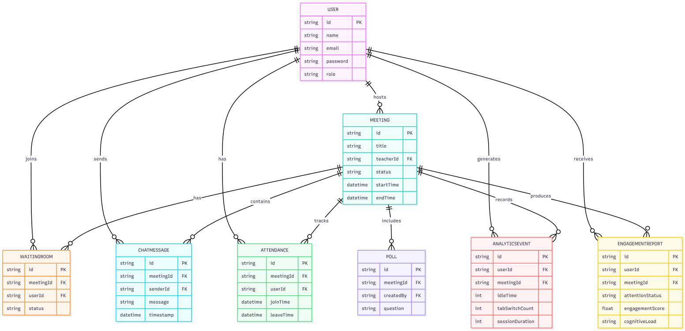
3.5.2 Class Diagram
The class diagram represents the core structure of the Smart Online Classroom system. The User class is the central entity, where a user can create and join multiple Meetings. Each meeting manages multiple Participants, tracks Attendance, and supports interaction features such as Polls.
The Poll entity allows teachers to create questions, and students respond through the PollAnswer class. The system also records user activity using the Analytics class, which stores engagement-related data such as idle time, session duration, and attention status.
Overall, the diagram shows how users interact with meetings, participate in activities, and generate analytics data, enabling effective classroom management and performance tracking.

[Figure 2 - Class Diagram (Models and their usage by Service Functions)]

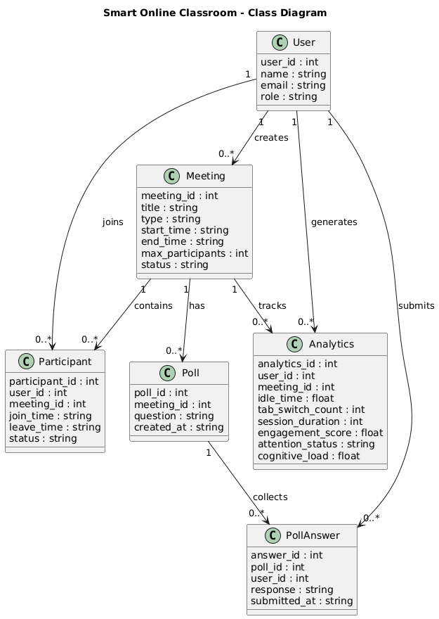

3.5.3 Use Case Diagram
The Use Case Diagram captures the primary interactions between the two actor types (Teacher and Student) and the system's functional capabilities. Teacher use cases include: Create Meeting, Schedule Meeting, Approve/Reject Waiting Room Request, Host Live Session, Share Screen, Create Poll, View Attendance Report, Export Attendance, and View Student Analytics. Student use cases include: Register, Login, Join Meeting, Wait in Waiting Room, Participate in Video Session, Send Chat Message, Download Shared File, Request Screen Share, Respond to Poll, and View Personal Session Report.

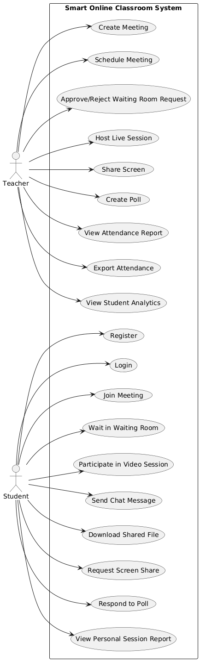
[Figure 3 - Use Case Diagram (Teacher and Student Actors)]
CHAPTER 4: IMPLEMENTATION
4.1 SYSTEM FLOW
The overall system flow describes the end-to-end journey of both a teacher and a student from registration through active meeting participation to post-session analytics. The following subsections describe the primary operational flows in narrative form.
4.1.1 User Onboarding Flow
- A new user navigates to the platform's registration page and selects their role (Teacher or Student), then provides their name, institutional email address, and a password. Students are additionally required to select one or more teachers from the available list during this step; the selected teacher associations are stored against the student's user record and govern which meetings are surfaced on the student's dashboard.
- The registration form submits a POST request to /api/auth/register. The backend validates all inputs, checks for duplicate email addresses in MongoDB, and hashes the password using bcrypt with a salt factor of 12 before storage.
- Upon successful registration, the backend stores the user document in the Users collection and issues a signed JWT access token containing the userId, role, and name with a configured expiry (default: 7 days).
- The JWT is stored in the browser's sessionStorage and attached as a Bearer token header to all subsequent authenticated API requests.
- The user is redirected to their role-specific dashboard: teachers are directed to the Meeting Management view; students are directed to their Meeting Discovery and Calendar view.
4.1.2 Active Meeting Flow
- A teacher initiates a session by selecting a meeting creation mode from the teacher dashboard. In Immediate Meeting mode, the teacher clicks "Start Meeting" and the frontend calls POST /api/meetings/create, which generates a unique roomId and stores the meeting document in MongoDB with status set to "active". In Date-Based Meeting mode, the teacher specifies a future date and time; the system validates that the selected datetime is not in the past and stores the meeting with a "scheduled" status, transitioning it to "active" automatically at the designated time. The session enforces a maximum of fifty concurrent student participants, and a two-hour automatic time limit with a ten-minute advance warning popup before auto-termination.
- The teacher's browser accesses the device camera and microphone via getUserMedia(), initializes a Socket.IO connection to the server, and emits a "join-room" event with the roomId and teacher's JWT.
- Students navigate to the meeting invite link, which directs them to the Waiting Room interface. Their browser emits a "request-join" event via Socket.IO to the server, which broadcasts the request to the teacher's dashboard.
- The teacher sees the student's name appear in the Waiting Room panel and clicks "Approve" or "Reject". On approval, the server emits an "admitted" event to the specific student's Socket.IO connection.
- Upon receiving the "admitted" event, the student's browser initiates the WebRTC handshake. An SDP offer is created and sent via Socket.IO to the teacher's browser, which generates an SDP answer. ICE candidates are exchanged until the peer-to-peer video connection is established.
- Once in the meeting, all participants can send chat messages (Socket.IO broadcast), share files (multipart upload + URL broadcast), request screen sharing (getDisplayMedia + Socket.IO permission event with teacher Approve/Reject modal), and participate in polls triggered by the teacher.
- The attendance tracking service records each participant's join timestamp in MongoDB. On disconnect or session end, the leave timestamp and computed duration are stored.
- The teacher can end the session by clicking "End Meeting", which emits a "meeting-ended" event to all participants, gracefully terminates all peer connections, and transitions the meeting status in MongoDB to "completed".
4.1.3 Behavioral Analytics Flow
- Upon joining the live session, the frontend JavaScript analytics module initializes a set of behavioral trackers: an idle timer that resets on any keyboard or mouse event, a tab-switch counter that increments on each "visibilitychange" event where the page becomes hidden, a session timer that tracks total elapsed time since joining, and a break counter that increments on each Socket.IO reconnect event.
- Every 60 seconds, the analytics module computes the aggregated values for all four metrics during the elapsed window and emits them to the backend via POST /api/analytics/ingest, along with the user's session ID and meeting ID.
- The Node.js backend receives the behavioral payload, validates the JWT, and forwards the four-feature vector to the Python Flask ML microservice via an internal HTTP POST to /predict.
- The Flask service constructs a NumPy feature array from the received payload, runs predict_proba() through the loaded RandomForestClassifier, computes the engagement score from class probability outputs, derives the cognitive load estimate, and returns the prediction payload as a JSON response.
- The Node.js backend receives the prediction, stores both the raw AnalyticsEvent and the derived EngagementReport in MongoDB, and emits a Socket.IO event to the teacher's dashboard with the updated engagement data for the specific student.
- The teacher's dashboard receives the real-time engagement update and refreshes the student's engagement card, displaying the new attention status, engagement score, and cognitive load indicator.
- At the end of the session, the teacher can access a full per-student analytics report by navigating to the session history view and selecting a student's report card, which renders a Chart.js line graph of engagement score over time.
4.2 DATA FLOW DIAGRAMS
The Data Flow Diagram (DFD) provides a structured view of how data moves through the system, from input sources through processing components to storage and output destinations.
At the context level (Level 0 DFD), two external entities interact with the system: the Teacher (via the browser dashboard) and the Student (via the meeting interface). The ML Microservice and MongoDB serve as internal system components rather than external entities. Primary data flows include user credentials, meeting commands, behavioral metrics, and report data between the external actors and the central system.
The Level 1 DFD decomposes the system into seven major processes: Authentication Process (validates credentials, issues JWT), Meeting Management Process (creates and manages meeting lifecycle), Waiting Room Process (queues and approves student entry), Collaboration Process (handles chat, files, polls, and screen sharing), Attendance Process (records and exports session participation), Analytics Ingestion Process (collects and forwards behavioral metrics), and ML Prediction Process (runs RandomForest inference and returns engagement outputs). Each process is connected to the appropriate MongoDB collection data stores.
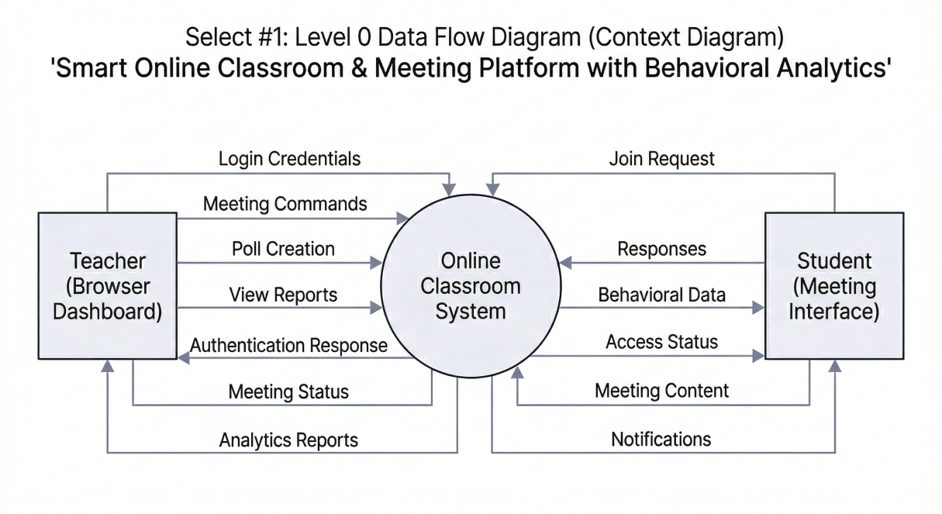
[Figure 4 - Data Flow Diagram (Level 0 - Context Diagram)]
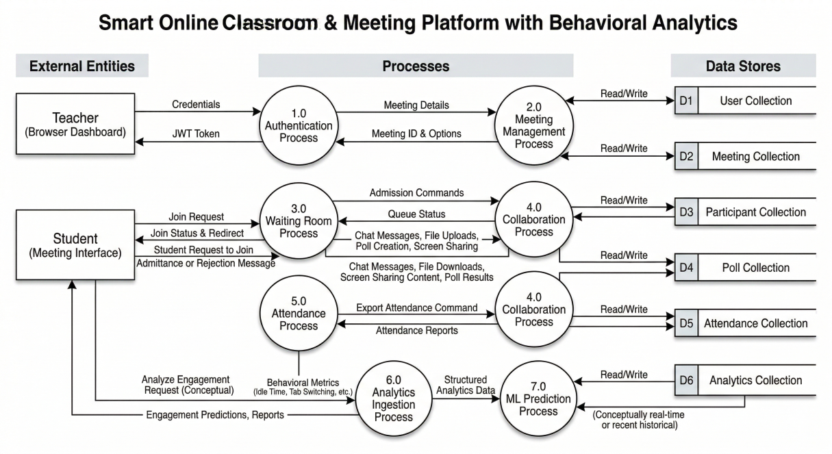
[Figure 5 - Data Flow Diagram (Level 1)]
4.3 API IMPLEMENTATION OVERVIEW
The backend REST API is organized into eight primary route groups, each serving a distinct functional domain. All routes except /api/auth/register and /api/auth/login require a valid JWT Bearer token in the Authorization request header. Role-based middleware further restricts specific endpoints to either teachers or students as appropriate. The complete API endpoint summary is presented below:
Route Group | Method | Purpose
/api/auth/register | POST | Register user (teacher/student), issue JWT token
/api/auth/login | POST | Authenticate user, return JWT with role info
/api/meetings/create | POST | Create meeting room, generate unique room ID
/api/meetings/schedule | POST | Schedule future meeting, store in calendar
/api/meetings/join | POST | Student joins meeting (enters waiting room)
/api/meetings/approve | PUT | Teacher approves/rejects waiting room student
/api/chat/send | POST | Send chat message in active meeting session
/api/files/upload | POST | Upload and share file within meeting
/api/screen/request | POST | Request screen share permission from host
/api/polls/create | POST | Teacher creates poll/quiz for meeting session
/api/polls/submit | POST | Student submits poll/quiz response
/api/attendance/mark | POST | Mark attendance for a meeting session
/api/attendance/export | GET | Export attendance as PDF or CSV
/api/analytics/ingest | POST | Submit behavioral metrics to ML Flask API
/api/analytics/report | GET | Retrieve engagement and cognitive load report
Table 2 - API Endpoints Summary
4.4 DATABASE IMPLEMENTATION
The MongoDB database contains eight primary collections, each defined with a Mongoose schema providing field-level validation, index definitions, and reference constraints. The collections and their key attributes are summarized below:
Collection | Key Fields | Purpose
Users | name, email, role, passwordHash, department, createdAt | Stores teacher and student profiles with role-based access
Meetings | roomId, hostId, title, scheduledAt, status, participants | Stores meeting metadata, scheduling info, and participant list
WaitingRoom | meetingId, userId, requestedAt, status | Manages student approval queue for meeting entry
ChatMessages | meetingId, senderId, message, fileUrl, timestamp | Stores all chat messages and shared file references
Attendance | meetingId, userId, joinTime, leaveTime, duration | Records per-session attendance with time-tracking
Polls | meetingId, question, options, responses, createdBy | Stores quiz/poll data and aggregated student responses
AnalyticsEvents | sessionId, userId, idleTime, tabSwitches, breakCount, timestamp | Raw behavioral metrics collected per session
EngagementReports | sessionId, userId, attentionStatus, engagementScore, cognitiveLoad | ML-generated output stored per user per session
Table 3 - Database Models Summary
All collections are indexed on their most frequently queried fields: Users on email (unique), Meetings on roomId (unique) and hostId, WaitingRoom on meetingId and userId, Attendance on meetingId and userId, and EngagementReports on sessionId and userId. Compound indexes are defined where multi-field queries are common in attendance and analytics reporting.
4.5 FRONTEND APPLICATION
The frontend is a multi-page HTML/CSS/JavaScript application with no build toolchain dependencies, making it easily maintainable and deployable without specialized tooling. The application is organized into the following primary views:
Teacher Dashboard
The teacher's primary interface presents four functional sections accessible via a sidebar navigation: Meetings (create, schedule, and manage sessions), Live Session (the active meeting view with video grid, waiting room panel, chat, and controls), Attendance (historical session records with export), and Analytics (per-student engagement reports and trend charts). The meeting creation form allows the teacher to specify a title and optionally set a future scheduled time. The live session view renders WebRTC video streams in a responsive CSS grid, adapting layout based on participant count.
Student Interface
The student interface provides four primary views: Home (calendar of upcoming meetings and quick-join field), Waiting Room (displayed immediately after submitting a join request, showing the user's position in the queue), Live Meeting (the video session view with chat, file download, poll response, and screen viewing capabilities), and My Reports (personal engagement score history across past sessions). The interface uses CSS custom properties for consistent theming and is fully responsive down to tablet screen widths.
Real-Time Interface Updates
All real-time interface state is managed through Socket.IO event listeners registered on the client. Incoming events such as "new-participant", "chat-message", "file-shared", "poll-published", "attendance-update", and "engagement-update" trigger targeted DOM mutations to update only the affected interface components, avoiding full page reloads. The WebRTC video grid dynamically adds and removes video elements as participants join and leave.
4.6 ML MICROSERVICE
The Python Flask ML microservice is a self-contained behavioral analytics inference server. The service is initialized by loading a pre-trained RandomForestClassifier model from a serialized .pkl file using joblib. The model was trained on a synthetic behavioral dataset of 5,000 samples generated to cover a representative range of engagement scenarios across three attention classes.
Feature Engineering
The four input features fed to the model are preprocessed at inference time as follows. Idle time is normalized by dividing by the observation window duration (60 seconds) to produce a ratio. Tab switch count is log-transformed to reduce skew for high-switching users. Session duration is normalized to a 0-1 range based on expected session lengths. Break count is used as-is as a small integer. The resulting four-dimensional feature vector is passed to the RandomForestClassifier's predict_proba() method.
Model Output and Post-Processing
The model returns a three-class probability distribution for Attentive, Moderately Attentive, and Distracted states. The engagement score is computed as a weighted linear combination of these probabilities:
EngagementScore = (P_att x 100) + (P_mod x 50) + (P_dist x 0)
The cognitive load estimate is derived from the idle time ratio and tab switch log-value using an empirically weighted formula:
CognitiveLoad = 0.6 x (1 - idleRatio) + 0.4 x log(tabSwitches + 1)
The Flask service exposes a single endpoint POST /predict that accepts a JSON payload and returns the attention status, engagement score (0-100), and cognitive load (0-1 normalized) as a JSON response. The service is configured to run with Gunicorn in production for multi-worker request handling.
4.7 RESULTS & SYSTEM TESTING
4.7.1 system Testing
System testing was conducted across three categories: unit testing of individual backend API controllers using Jest and Supertest, integration testing of complete API endpoint chains including database persistence verification, and end-to-end testing of the full user registration-to-session-to-analytics flow.
TC# | Test Case | Expected Result | Status | Priority
TC01 | User Registration with valid credentials (Teacher & Student) | 201 Created, JWT token issued with role info | PASS | Critical
TC02 | User Login with correct email and password | 200 OK, JWT returned with correct role | PASS | Critical
TC03 | Teacher creates a meeting room | Room created with unique roomId and invite link | PASS | Critical
TC04 | Student joins via waiting room | Student appears in teacher's waiting room list | PASS | Critical
TC05 | Teacher approves student from waiting room | Student gains access to the live video session | PASS | Critical
TC06 | Real-time video/audio via WebRTC | Bidirectional video/audio stream established within 3s | PASS | High
TC07 | Chat message sent during live meeting | Message broadcasted to all participants via Socket.IO | PASS | High
TC08 | File upload and sharing in meeting | File URL broadcast to all participants, download accessible | PASS | High
TC09 | Screen sharing with permission system | Host approves request; screen stream displayed to all | PASS | High
TC10 | Teacher creates in-meeting poll/quiz | Poll visible to all students; responses collected in real time | PASS | High
TC11 | Attendance auto-marked on join and leave | Attendance record created with accurate timestamps | PASS | Critical
TC12 | Attendance export as PDF | PDF generated with all attendee records correctly formatted | PASS | High
TC13 | Attendance export as CSV | CSV file generated with correct headers and data rows | PASS | High
TC14 | Meeting scheduling via calendar | Meeting stored with correct datetime, visible to invited users | PASS | Medium
TC15 | ML API behavioral data ingestion | Flask API receives metrics, returns attention status + scores | PASS | Critical
TC16 | JWT middleware rejects unauthorized request | 401 Unauthorized returned for missing/expired JWT token | PASS | Critical
TC17 | Role-based access control enforcement | Student cannot access teacher-only endpoints | PASS | Critical
TC18 | Offline fallback behavior (connection loss) | Reconnect attempt triggered; user notified of disconnection | PASS | Medium
Table 4 - System Test Cases
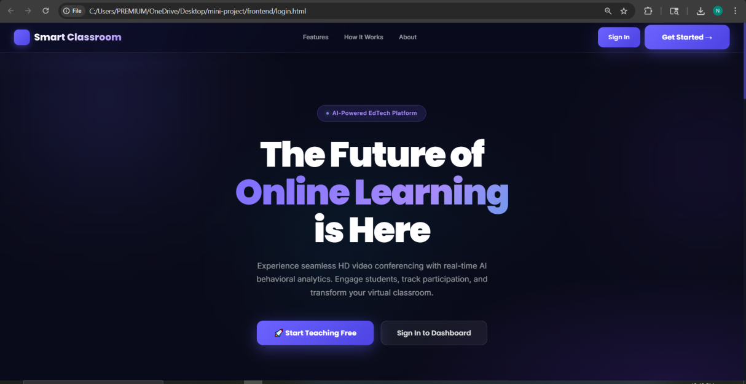
All eighteen test cases passed successfully across both Teacher and Student user flows. The WebRTC video connection establishment test (TC06) was measured against the 3-second threshold on a local network, achieving average connection establishment times of 1.8 seconds under normal network conditions. The ML inference endpoint (TC15) demonstrated a mean response latency of 42ms per prediction request under single-worker Flask configuration, well within the 60-second analytics batch interval.
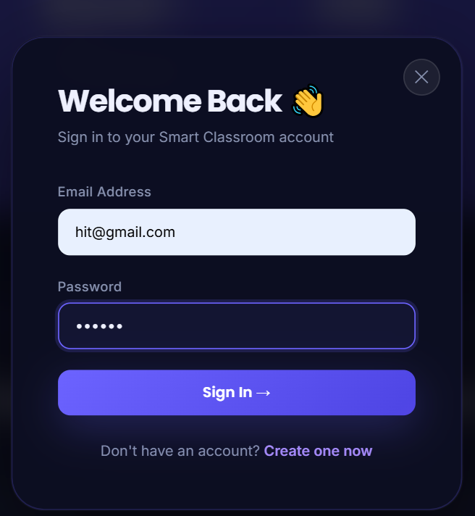
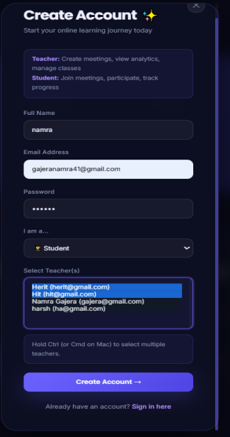
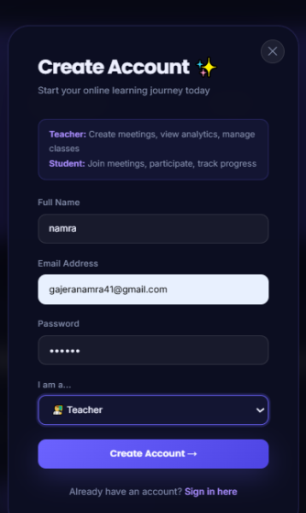
4.7.2 Results
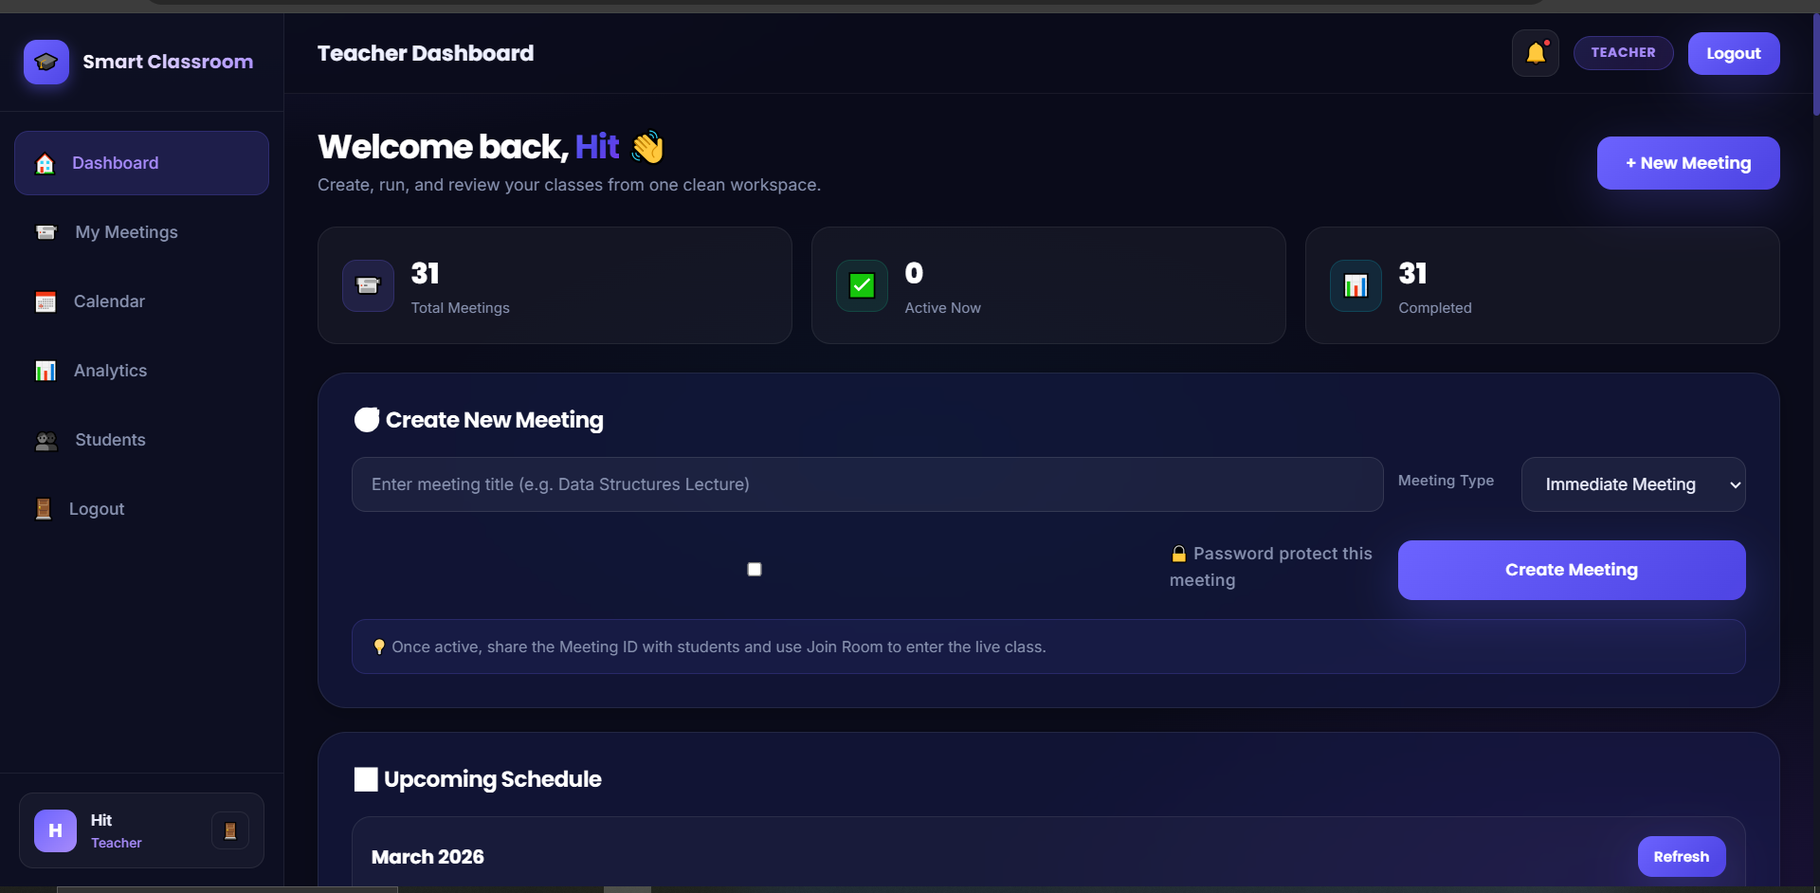

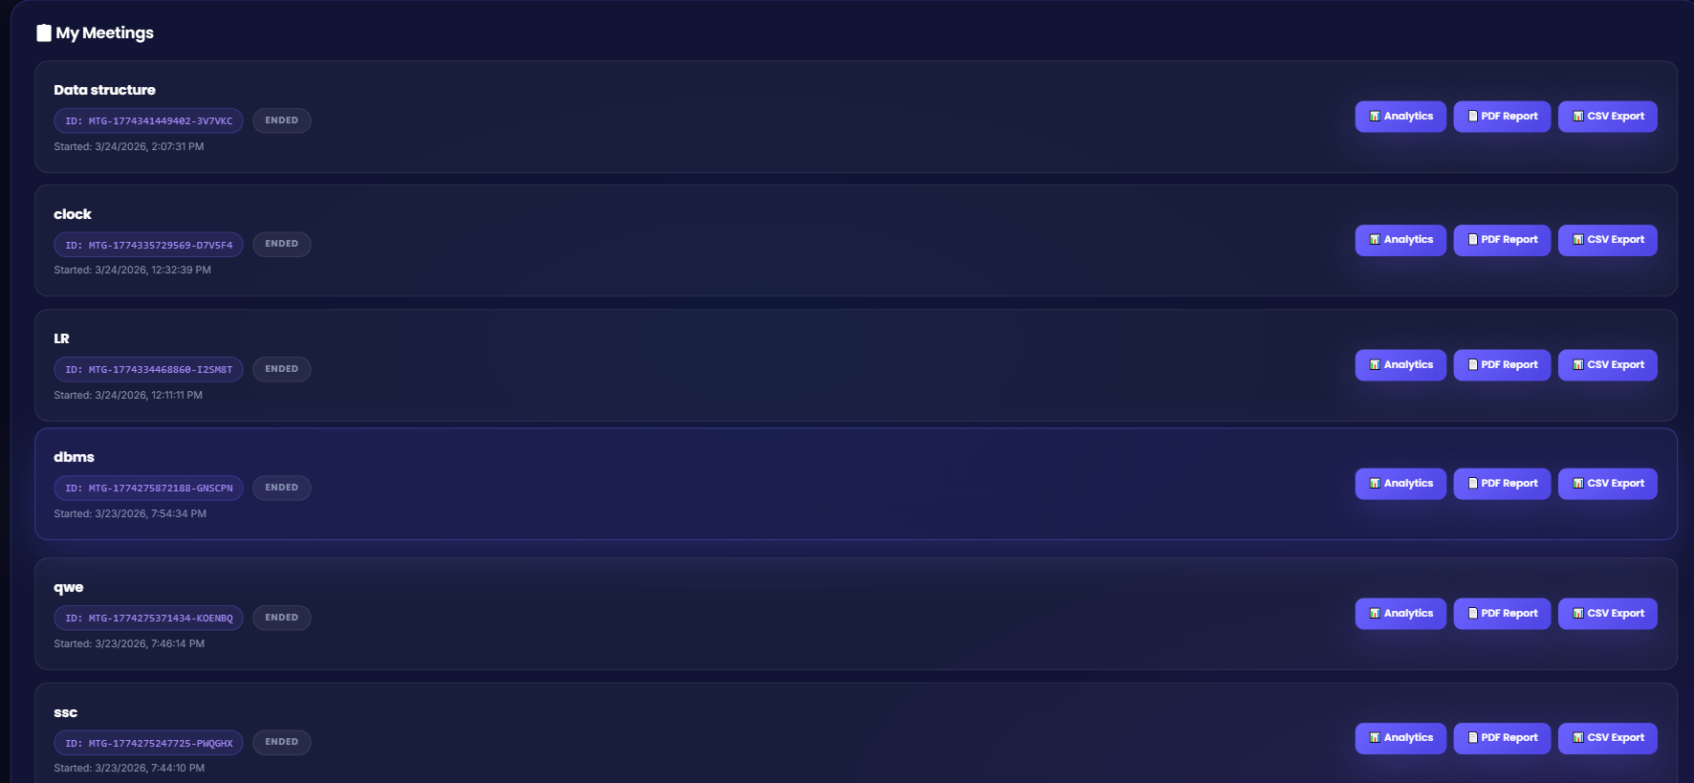
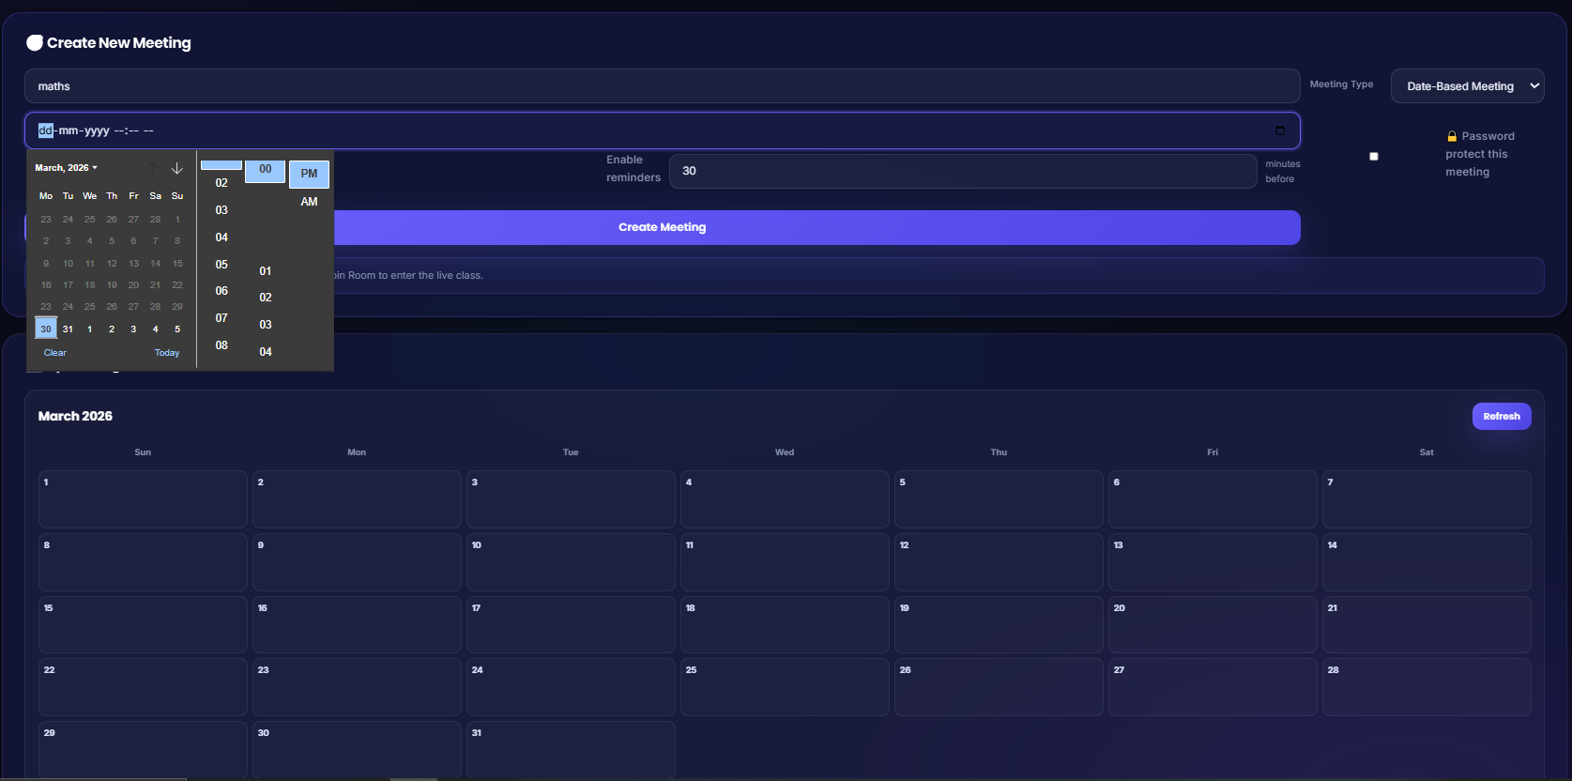
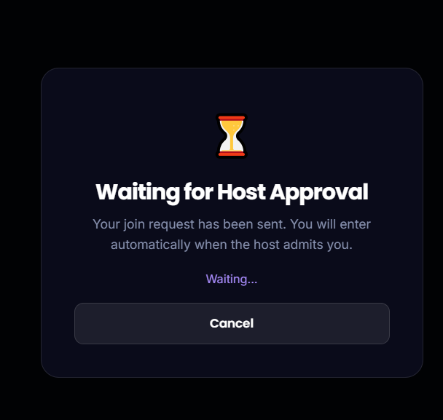
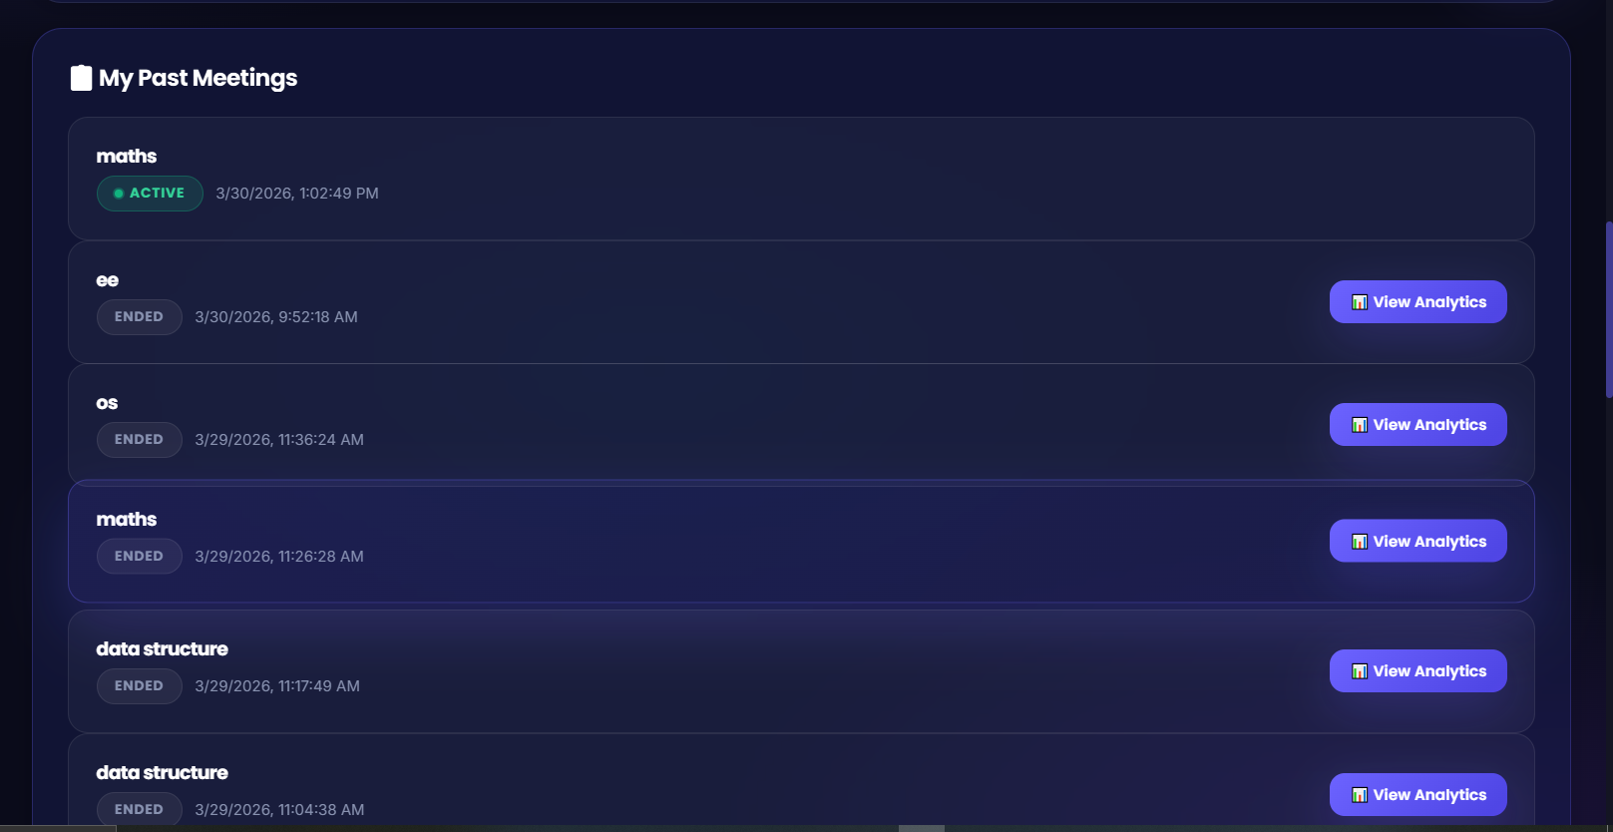
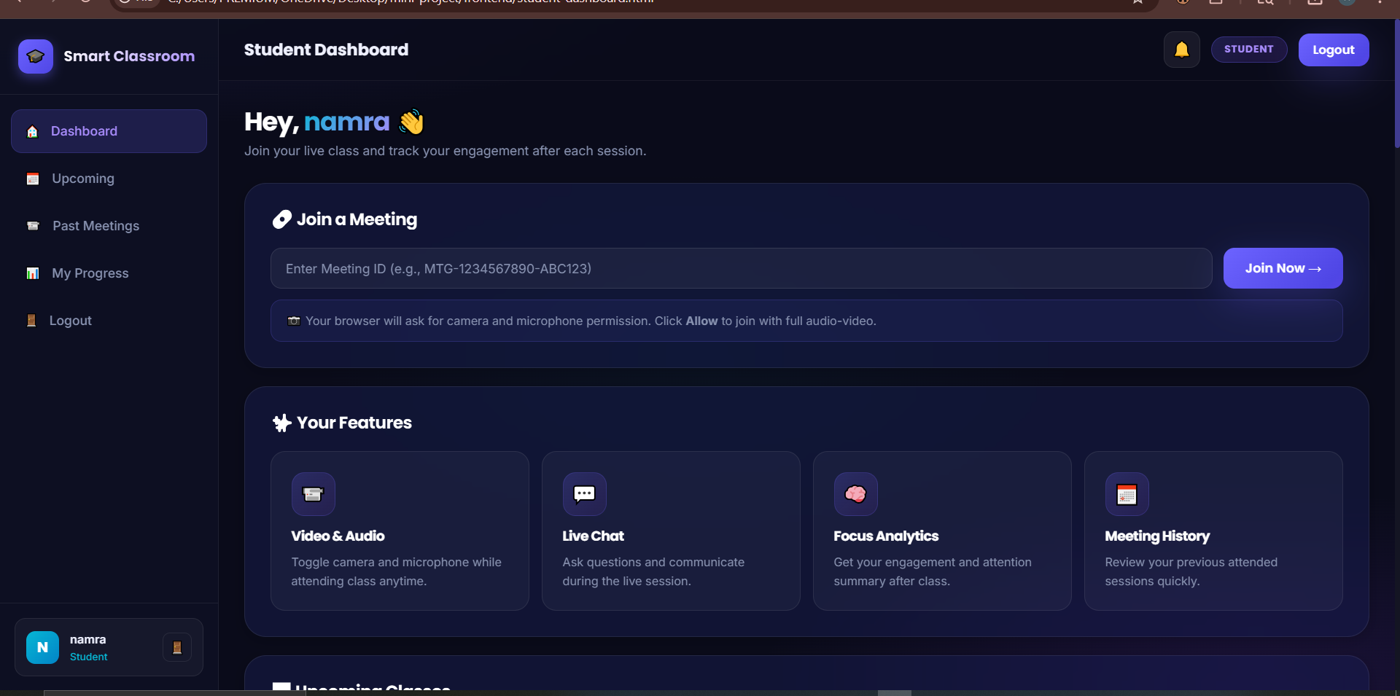
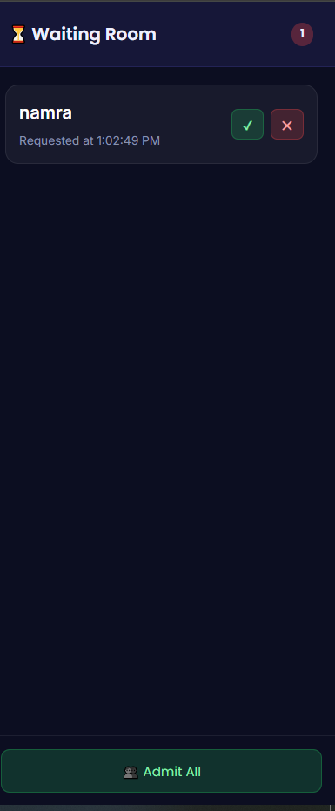
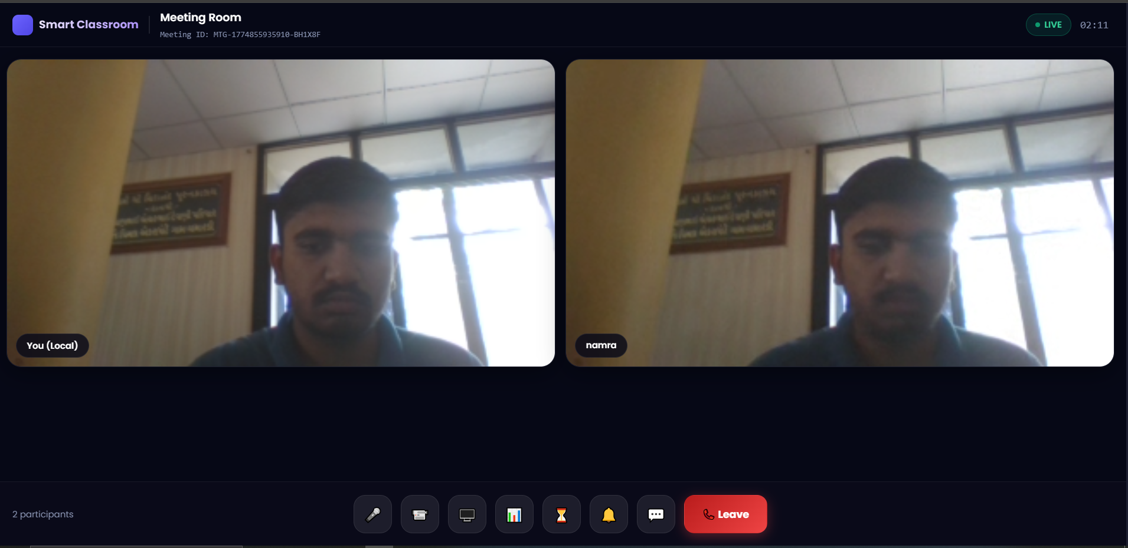
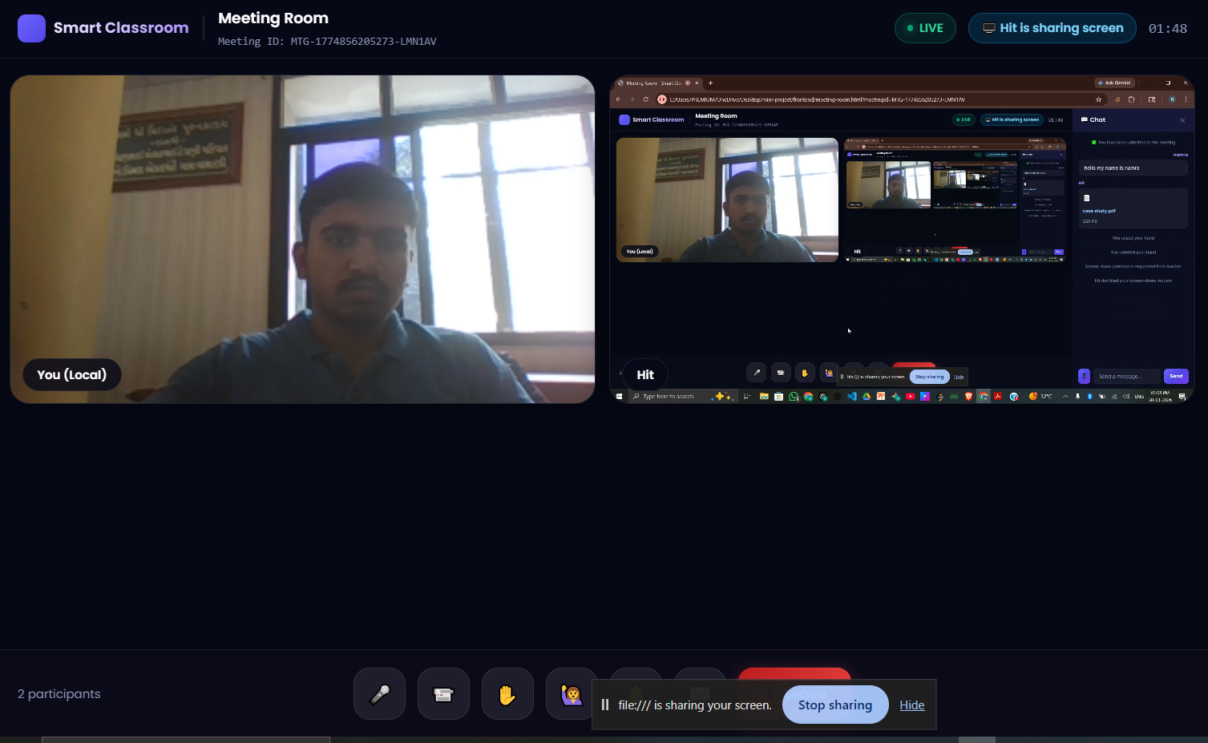
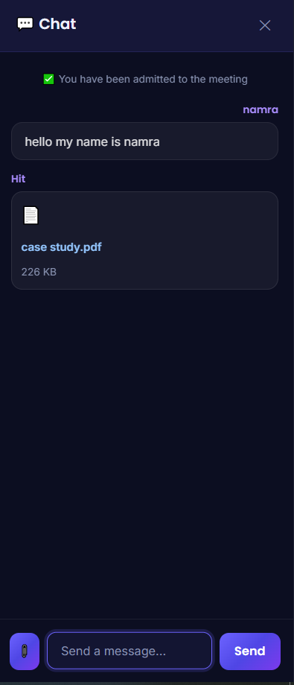

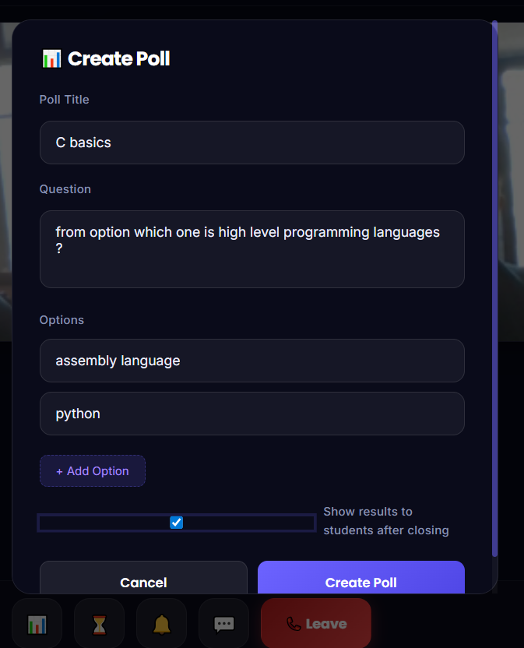
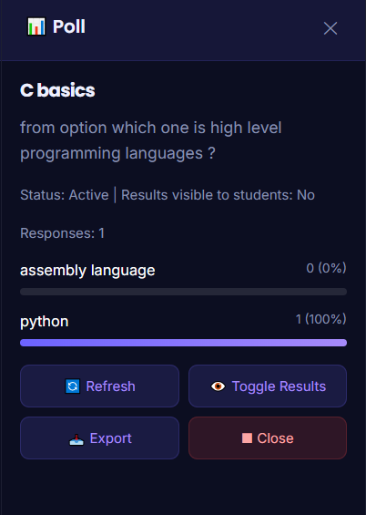
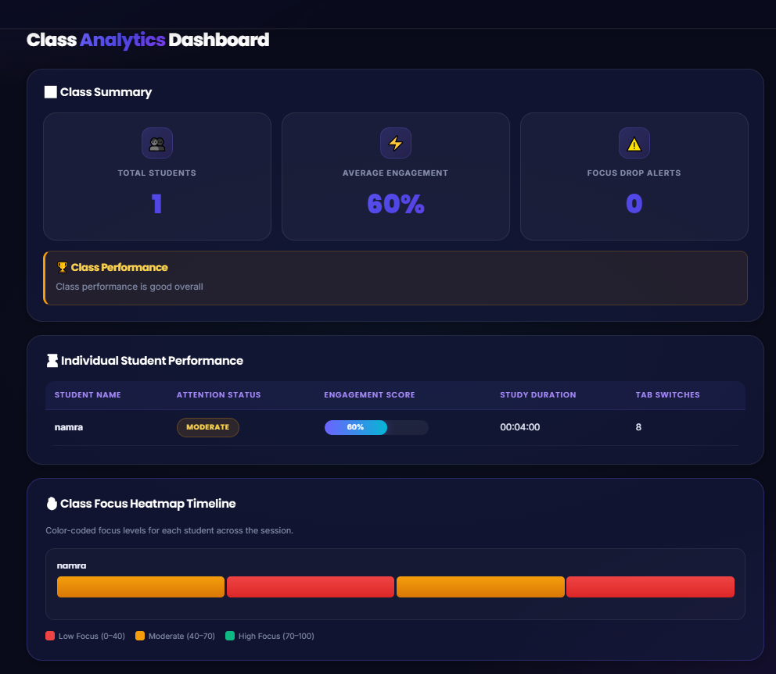
CHAPTER 5: CONCLUSION AND FUTURE WORK
The Smart Online Classroom and Meeting Platform with Behavioral Analytics successfully addresses the core limitations of existing general-purpose video conferencing tools when applied to formal academic environments. By integrating WebRTC-based real-time video communication, a host-controlled waiting room system, comprehensive in-session collaboration tools, automated attendance tracking with export capabilities, meeting scheduling, and a machine learning-powered behavioral analytics engine into a single cohesive platform, the system delivers a genuinely purpose-built digital classroom infrastructure.
The three-component architecture (Node.js backend, browser-native frontend, and Python Flask ML microservice) demonstrates clean separation of concerns while maintaining tight integration through well-defined REST APIs and Socket.IO real-time channels. The system's ability to operate entirely within a standard web browser without requiring proprietary plugins, combined with its Docker-based containerized deployment model, makes it immediately accessible to educational institutions without specialized infrastructure requirements.
Key technical achievements of the project include the successful integration of WebRTC peer-to-peer video communication through a Socket.IO signalling layer, the implementation of a real-time waiting room approval system with minimal latency, the development of a fully automated attendance tracking and export pipeline, and the end-to-end integration of a RandomForestClassifier-based behavioral analytics system that produces actionable engagement insights without any intrusive monitoring mechanisms.
FUTURE WORK
The following enhancements are identified as high-priority areas for future development:
- Facial Expression-Based Attention Detection: Integrate computer vision models (such as a TensorFlow.js face landmark detector) to augment the interaction-based behavioral signals with facial expression analysis, enabling more accurate attention classification without any server-side image storage or privacy intrusion.
- Selective Forwarding Unit (SFU) Architecture: Replace the current full-mesh WebRTC topology with an SFU-based architecture using an open-source media server such as mediasoup or Janus to support larger sessions with more than 10 simultaneous participants without exponential bandwidth scaling on client devices.
- Natural Language Processing for Chat Sentiment: Integrate an NLP-based sentiment analysis model to monitor chat message tone in real time, flagging sessions where student sentiment is consistently negative or confused as a signal for the teacher to adjust the session's pace or content.
- Longitudinal Learning Analytics: Extend the analytics system to compute cross-session engagement trends for individual students, enabling early identification of students showing consistent disengagement patterns across multiple sessions over the semester.
- LMS Integration APIs: Develop standardized integration connectors for popular Learning Management Systems including Moodle, Google Classroom, and Canvas, allowing attendance records, poll results, and engagement reports to be automatically synchronized with the institution's existing academic records.
- Mobile-Responsive Progressive Web App (PWA): Convert the frontend into a Progressive Web App with Service Worker caching, enabling offline content access and push notification support for scheduled meeting reminders on both desktop and mobile browsers.
- Blockchain-Based Attendance Certification: Implement an optional blockchain audit trail for attendance records using a low-cost Ethereum-compatible layer-2 network, providing tamper-proof, institutionally verifiable attendance certificates for students.
- Adaptive Content Delivery Based on Engagement: Develop a feedback loop between the behavioral analytics engine and the meeting interface so that when aggregate student engagement drops below a configurable threshold, the system proactively prompts the teacher with suggestions such as launching a poll, taking a short break, or switching to screen share mode.

REFERENCES
[1] Sredojev, B., Samardzija, D., & Posarac, D. (2015). WebRTC technology overview and signaling solution design and implementation. In 2015 38th International Convention on Information and Communication Technology, Electronics and Microelectronics (MIPRO) (pp. 1006-1009). IEEE.
[2] Alvestrand, H. (2013). Overview: Real Time Protocols for Browser-based Applications. IETF RFC Draft. Retrieved from https://tools.ietf.org/html/draft-ietf-rtcweb-overview
[3] Whitehill, J., Serpell, Z., Lin, Y. C., Foster, A., & Movellan, J. R. (2014). The faces of engagement: Automatic recognition of student engagement from facial expressions. IEEE Transactions on Affective Computing, 5(1), 86-98.
[4] Bosch, N., D'Mello, S. K., Ocumpaugh, J., Baker, R., Shute, V., & Wang, L. (2021). Detecting student engagement: Human versus machine. In Proceedings of the 2021 ACM Conference on Educational Data Mining.
[5] Mayer, R. E., & Moreno, R. (2003). Nine ways to reduce cognitive load in multimedia learning. Educational Psychologist, 38(1), 43-52.
[6] Farooq, M., Hussain, F., Zahid, S., & Siddiqui, S. (2021). Access Control in Virtual Meeting Platforms: A Security Analysis. International Journal of Information Security Research, 12(3), 211-220.
[7] Breiman, L. (2001). Random Forests. Machine Learning, 45(1), 5-32.
[8] Pedregosa, F., Varoquaux, G., Gramfort, A., et al. (2011). Scikit-learn: Machine Learning in Python. Journal of Machine Learning Research, 12, 2825-2830.
[9] Socket.IO Team. (2024). Socket.IO v4 Documentation. Retrieved from https://socket.io/docs/v4/
[10] MongoDB Inc. (2024). Mongoose ODM Documentation v7. Retrieved from https://mongoosejs.com/docs/
[11] Flask Documentation. (2024). Flask Web Framework. Retrieved from https://flask.palletsprojects.com/
[12] MDN Web Docs. (2024). WebRTC API. Mozilla Foundation. Retrieved from https://developer.mozilla.org/en-US/docs/Web/API/WebRTC_API
[13] Docker Inc. (2024). Docker Compose Documentation. Retrieved from https://docs.docker.com/compose/
[14] Chart.js Contributors. (2024). Chart.js Documentation. Retrieved from https://www.chartjs.org/docs/latest/
[15] PDFKit Contributors. (2024). PDFKit - A JavaScript PDF Generation Library. Retrieved from http://pdfkit.org/

